GCX-ONE Tower Monitoring Configuration Guide

Introduction
When we refer to Tower Monitoring in GCX-ONE, we are describing an integrated ecosystem of multiple IoT subsystems working together to ensure the tower’s operational continuity, energy efficiency, and communication reliability.
Each subsystem plays a distinct but interconnected role, contributing to the tower’s overall intelligence and autonomy.
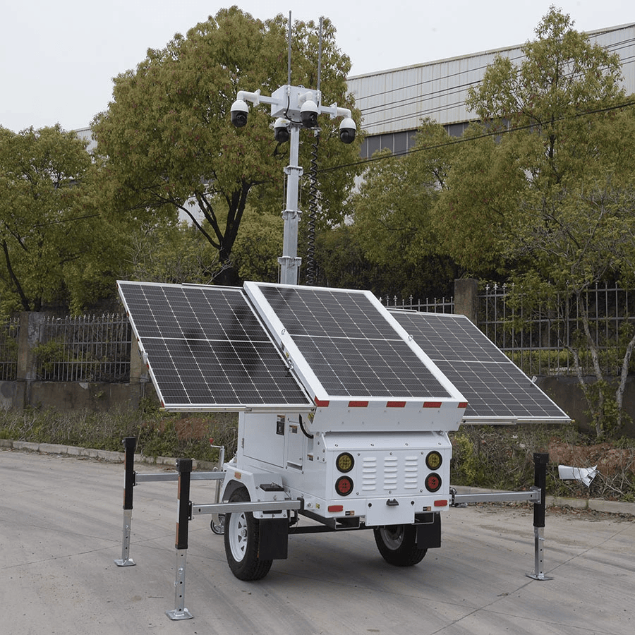

- Victron Energy oversees Power and Energy Monitoring, tracking parameters such as battery voltage, charging current, solar input, and load consumption. This ensures that the energy system operates within safe thresholds and provides early warning of battery or solar irregularities.

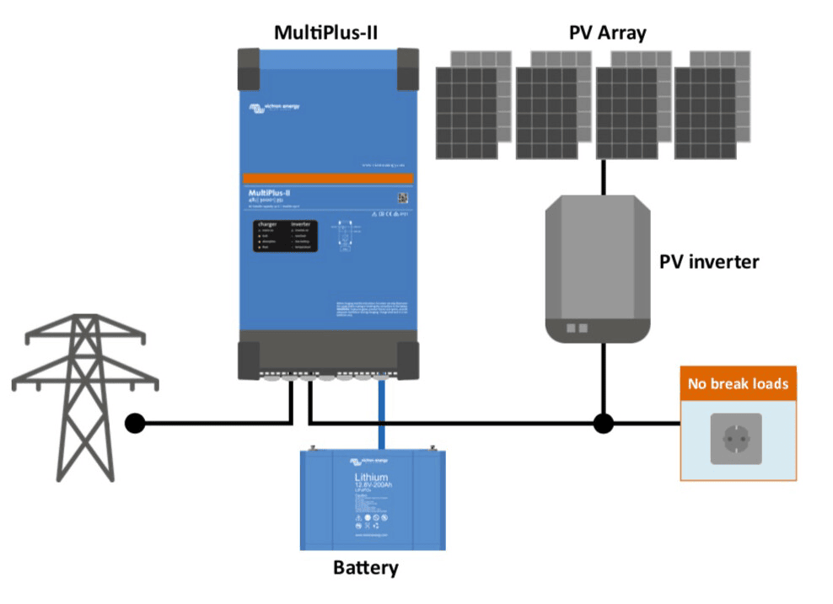
- EFOY Fuel Cells enable Fuel Cell Backup Monitoring, safeguarding critical uptime by reporting fuel levels, voltage output, state of charge, and internal temperature — essential for remote sites relying on autonomous energy sources.
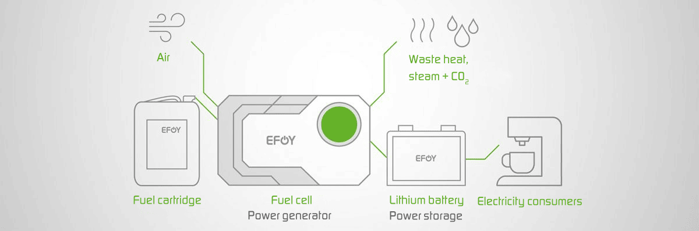
- Teltonika IoT Devices manage Network Connectivity and Device Health Monitoring, including mobile network quality, SIM data usage, geofencing, input/output state changes, and advanced jamming detection for communication assurance.
  - 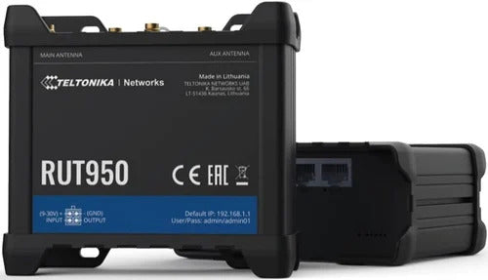
Together, these intelligent systems form a unified monitoring architecture within GCX-ONE. They continuously stream telemetry data from distributed towers into the GCX-ONE IoT cloud, where it is analyzed, stored, and correlated with configurable alarm rules.

System Overview
Each device — whether it’s a Victron solar/battery controller, EFOY fuel cell, or Teltonika router — periodically reports status and sensor values to GCX-ONE using secure communication channels.
These data points are evaluated in real time against pre-defined alarm thresholds and logic rules. When a condition breaches the configured limits, GCX-ONE automatically:
- Generates event alerts (using the assigned event codes and group codes).
- Notifies the appropriate operator or system, through respective CMS channels (Evalink, AmWin, Lisa, IMMIX, etc...)
- Tracks the event lifecycle, ensuring alerts are automatically cleared/restored when the parameters return to their normal range.
This end-to-end monitoring pipeline transforms raw device data into actionable intelligence, allowing operators to detect risks early, respond faster, and maintain consistent tower uptime across all remote locations.

System Architecture
The Tower Monitoring architecture follows a distributed design that enables autonomous operation at remote tower sites while maintaining centralized visibility and control through the GCX-ONE platform.
The diagram below illustrates how the Victron Energy, EFOY Fuel Cell, and Teltonika IoT subsystems interact within the tower ecosystem and how telemetry and alarms are transmitted to the command center.
At the site level, Victron manages solar and battery performance, EFOY ensures backup power availability, and Teltonika provides communication, GPS tracking, and edge telemetry routing. These subsystems communicate securely with their respective cloud services, where GCX-ONE collects real-time operational data through authenticated API channels.
Within GCX-ONE, this incoming data is normalized, correlated, and continuously analyzed against configured alarm rules. Any deviation—such as low battery voltage, reduced solar input, fuel depletion, or network loss—triggers an alarm routed automatically to the operator console or central monitoring system.
This distributed yet unified architecture ensures every tower operates independently in the field while maintaining synchronized health and alarm visibility across all sites in the GCX-ONE command center.
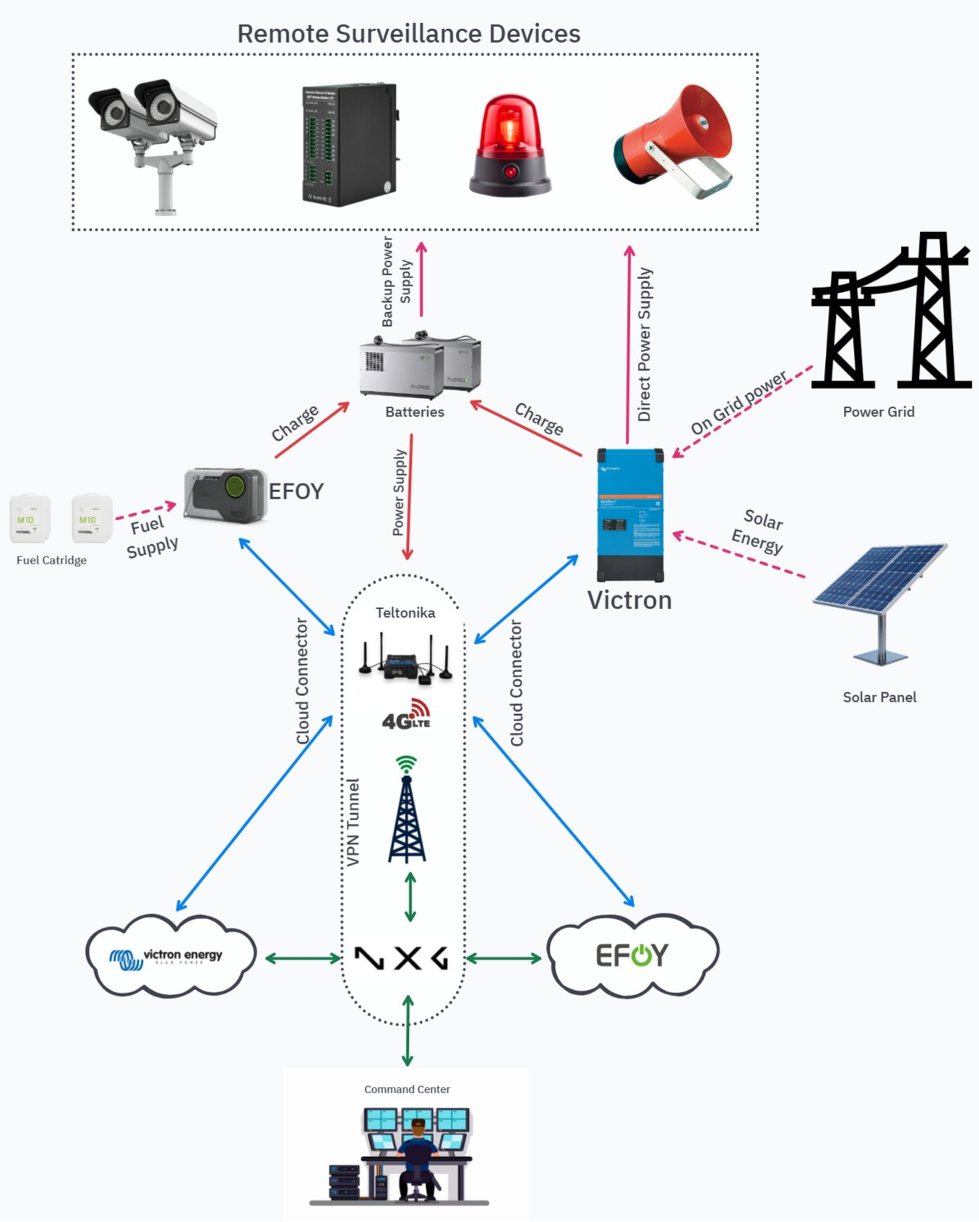
The Tower Monitoring architecture is organized in five layers that describe how field telemetry becomes alarms and operator actions in GCX-ONE.

Field Layer — Devices and Sensors
This layer contains the hardware installed at each tower site and the telemetry each device provides.
- Victron Energy devices (MPPTs, Battery Monitors, Inverters) supply power metrics such as battery voltage, charging current, state of charge, solar input, and system alarms. These devices are typically published to the Victron VRM cloud for remote access.
- EFOY Fuel Cells report fuel cartridge level, runtime estimates, output voltage, and internal temperature. They usually push data to the EFOY Cloud.
- Teltonika IoT routers handle network connectivity, GPS position, SIM data usage, input/output status, and jamming detection. They provide both status telemetry and remote I/O for site control.
Each device continuously collects sensor data and health indicators that are required for both routine monitoring and alarm detection.

Edge Communication Layer — Local and Mobile Links
This layer covers how devices reach the cloud when fixed infrastructure is not available.
- Victron devices forward telemetry to the Victron VRM service via internet connectivity provided by the site router or cellular uplink.
- EFOY devices forward to the EFOY Cloud using the configured cellular or gateway connection.
- Teltonika routers provide the primary WAN link for the tower, and may also expose local device endpoints (SNMP, HTTP, or vendor APIs) used by on-site systems.
The router also supplies remote access and optional VPN channels. Local I/O states and short term buffering occur here when connectivity is intermittent.

Cloud Aggregation Layer — Vendor Clouds and APIs
Vendor cloud platforms centralize device telemetry and present secure APIs that GCX-ONE consumes.
- Victron VRM API provides real time device metrics required for energy monitoring rules.
- EFOY Cloud API exposes fuel cell telemetry and status reports.
- Teltonika Cloud / Local API supplies router diagnostics, SIM usage statistics, GPS, and I/O states.
GCX-ONE connects to these cloud APIs using tenant level credentials, API keys, or account credentials to retrieve device lists, telemetry streams, and event logs.

Integration Layer — GCX-ONE IoT Engine
GCX-ONE normalizes vendor telemetry and applies alarm logic.
- GCX-ONE discovers devices via cloud API calls and registers them under the tenant and site mapping.
- Incoming telemetry is parsed and mapped to GCX-ONE device models (Energy Monitoring, Fuel Cell Monitoring, Connectivity Monitoring).
- Configurable alarm rules (JSON) evaluate the telemetry against thresholds, delays, and compound logic. Example rule groups include: Battery Voltage, Charger Status, Fuel Level, Network Loss, SIM Overuse, Input State Change, and Jammer Detection.
- When a rule is triggered, GCX-ONE generates an event with assigned event codes, stores related telemetry, and attaches any available verification media.

Monitoring Layer — Command Center and CMS Integration
This layer covers how operators receive and act on alerts.
- Events are routed to operator consoles via integrated CMS channels such as IMMIX, AmWin, Evalink, or LISA.
- Each event lifecycle is tracked: creation, escalation, acknowledgement, and automatic clear/restoration when parameters return to normal.
- GCX-ONE supports operator actions such as remote device commands (e.g., Teltonika remote restart, Victron remote setpoints if supported), notification workflows, and maintenance tickets.

Configuration Overview
In GCX-ONE, each tower integrates multiple device types — each with its own configuration logic and threshold rules. The configuration defines how the system interprets sensor values, detects abnormal conditions, and triggers the appropriate alerts.
This section explains how configuration is structured for the three core subsystems: Victron Energy, EFOY Fuel Cell, and Teltonika IoT Connectivity.

Victron Energy Monitoring Configuration
Victron devices act as the primary power monitoring system of the tower, focusing on solar charging performance, battery health, and overall DC system voltage.

Device Configuration Workflow (Common Steps)
Step 1: Log in to GCX-ONE.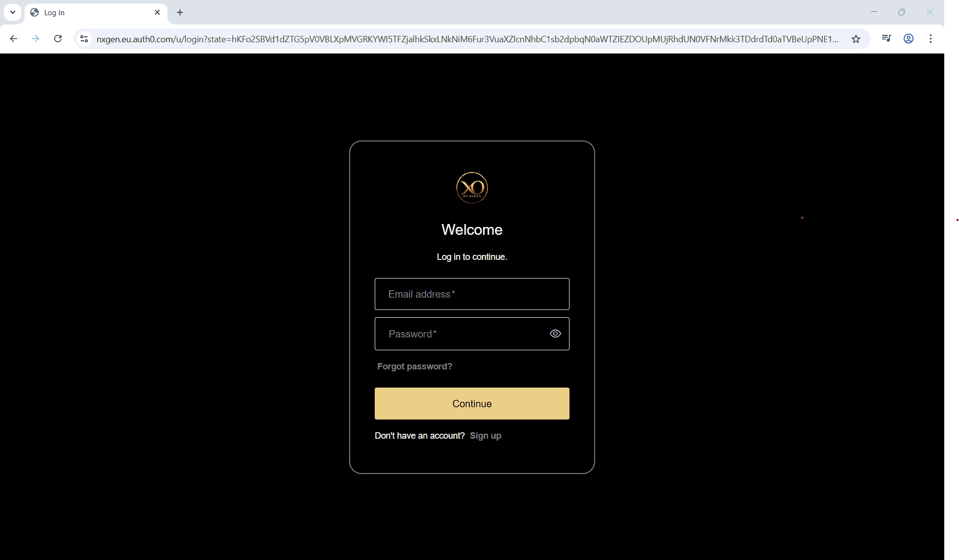
Step 2: Click on the Configuration menu.
Step 3: At the Service Provider level, click on Customers.
Step 4: Click the Add button.
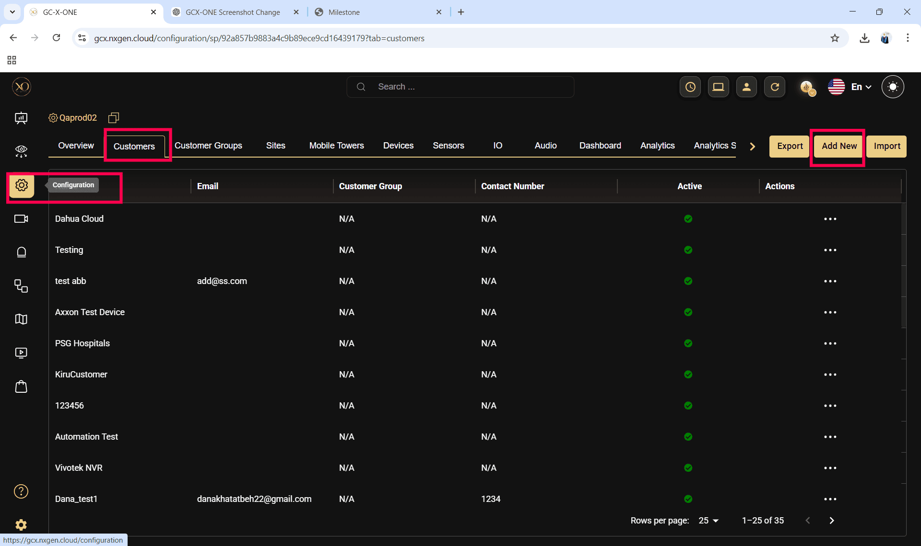

Step 5: Enter the required fields and click Save.
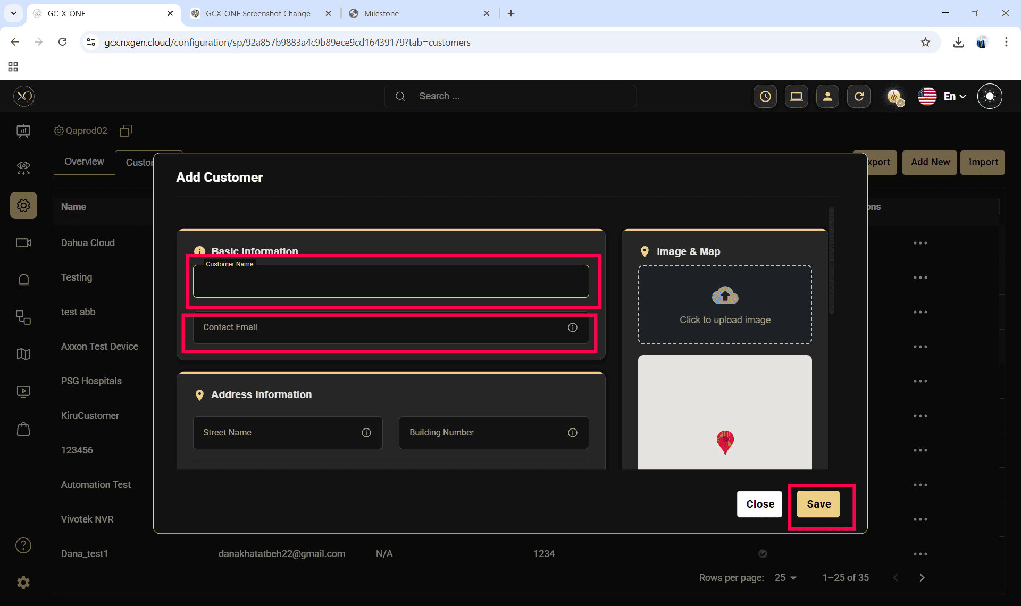

Step 6: Select the newly created customer.
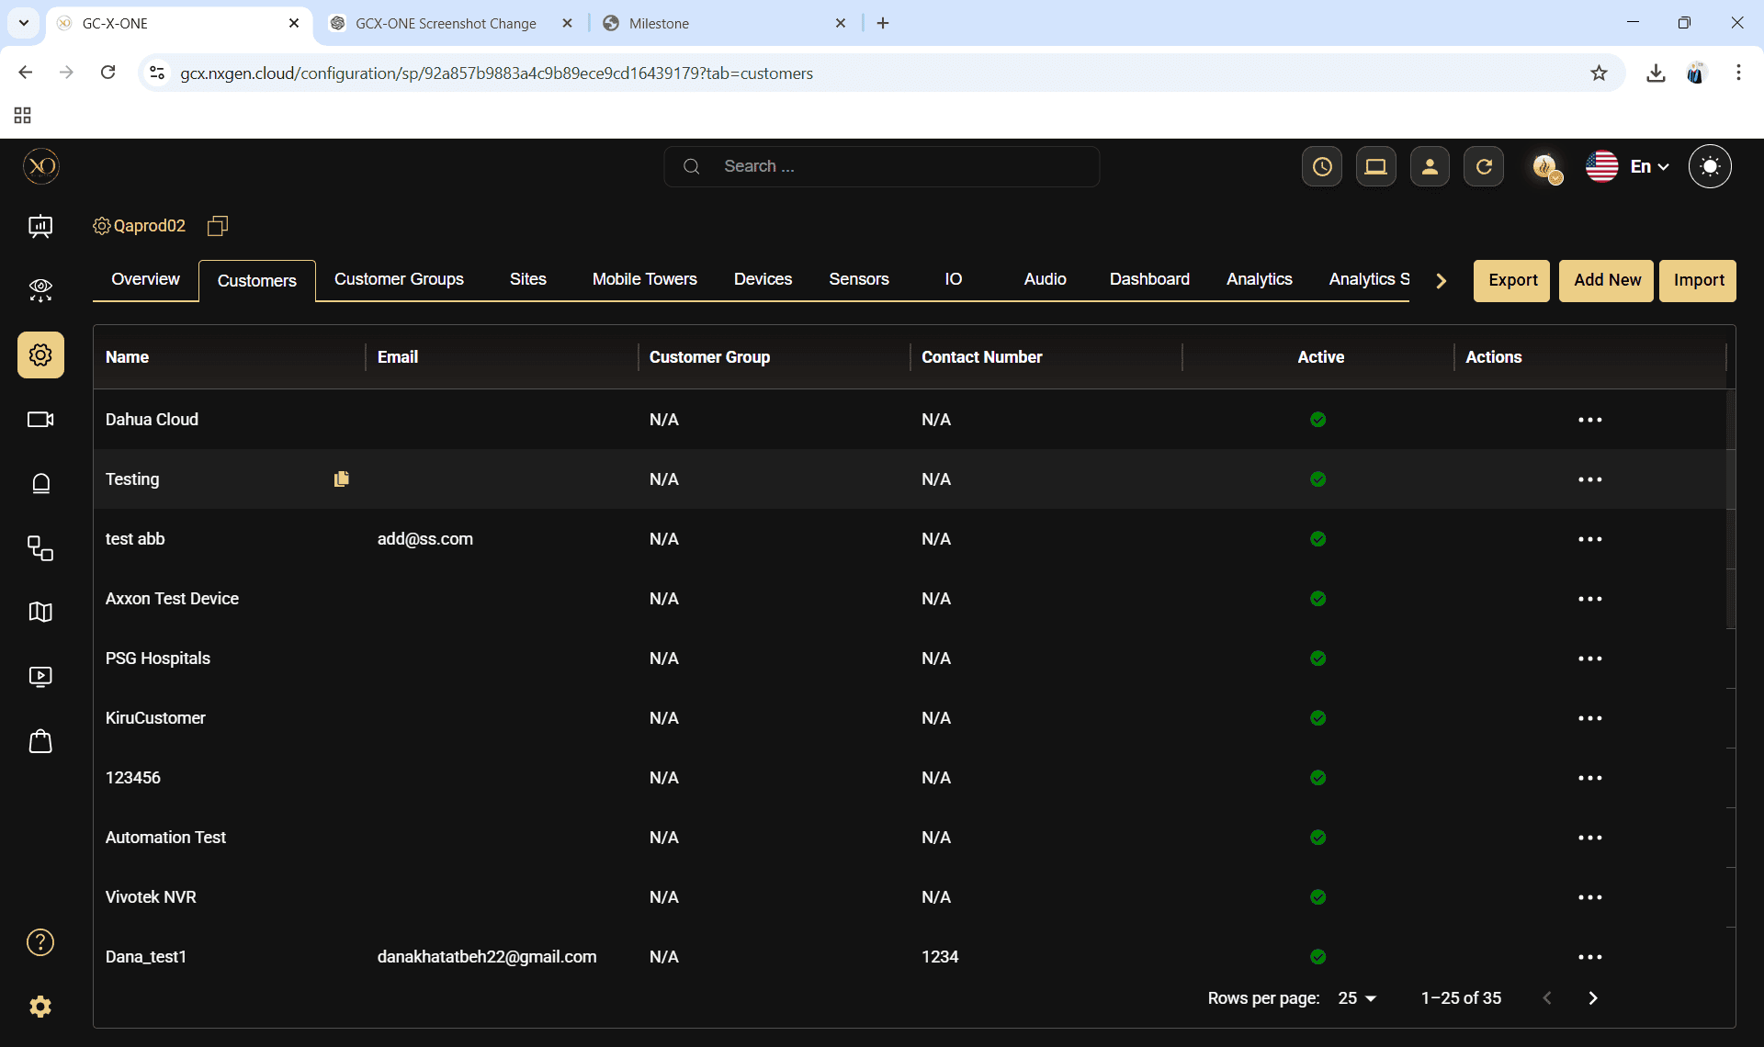
Step 7: Navigate to the Sites tab.
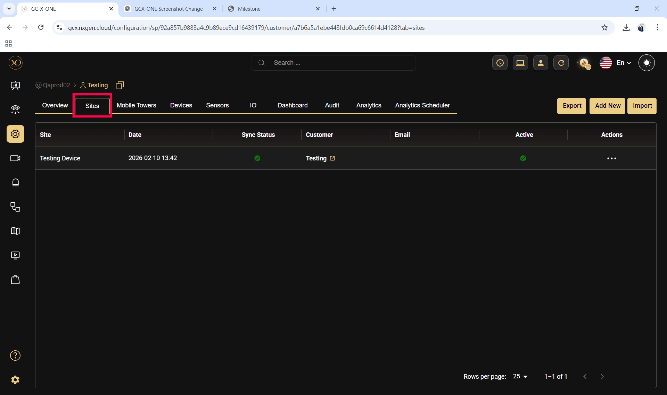

Step 8: Click the Add button.
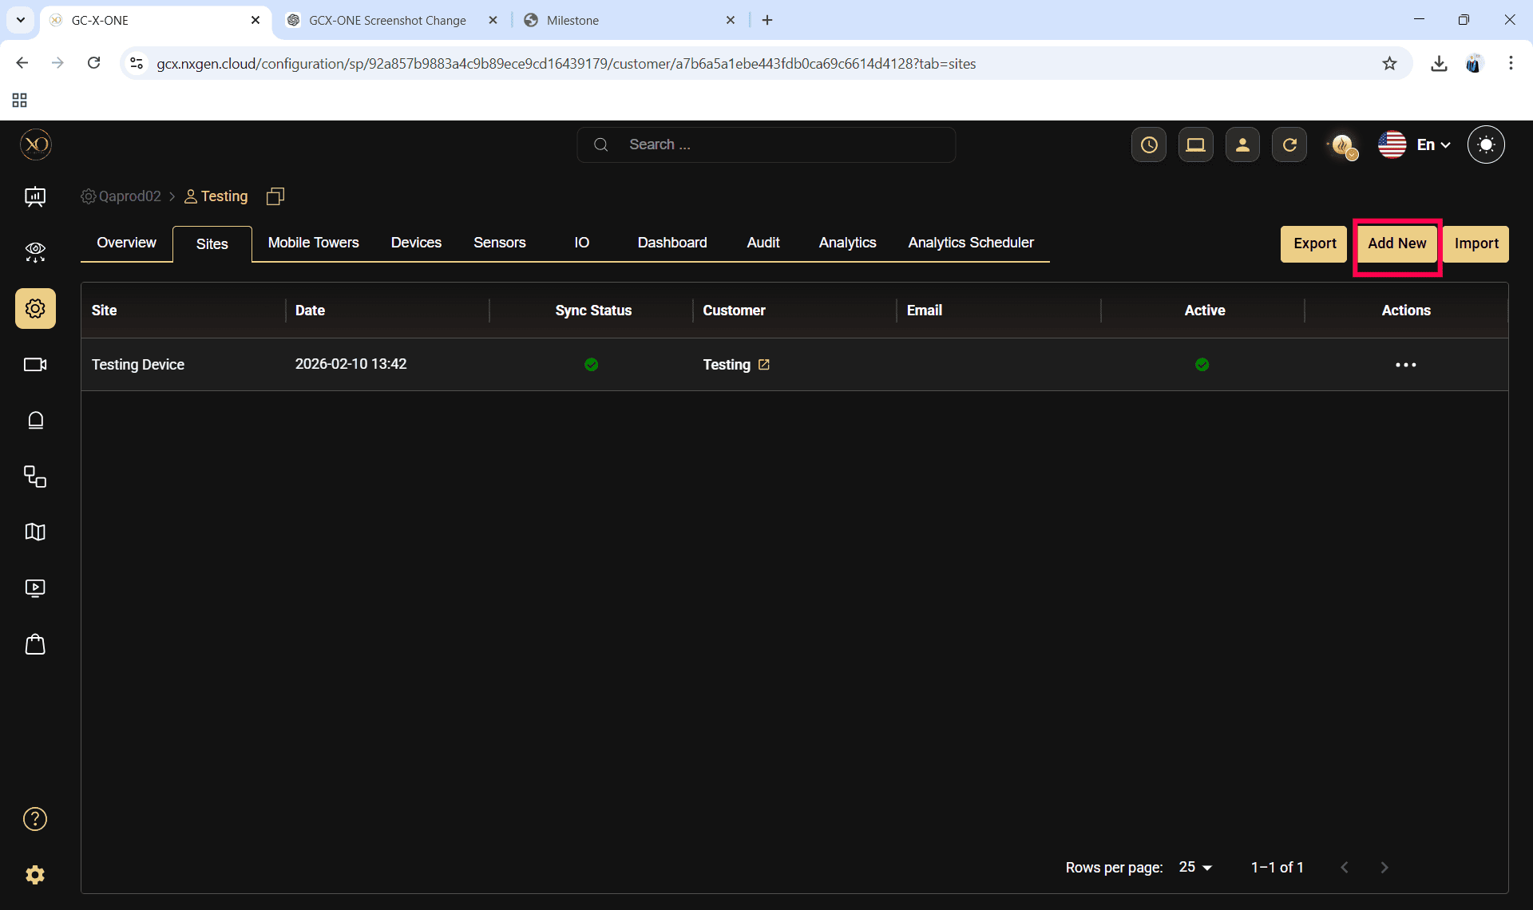
Step 9: Enter the required fields and click Save.
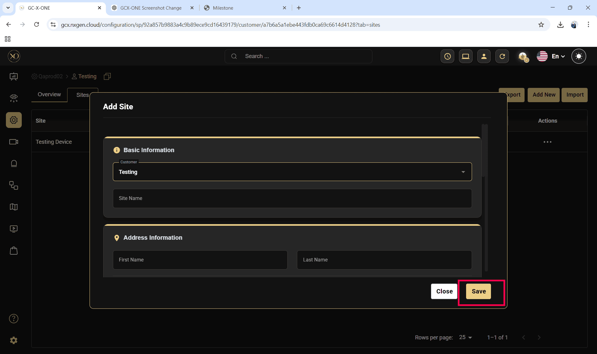

Step 10: Select the newly created site.
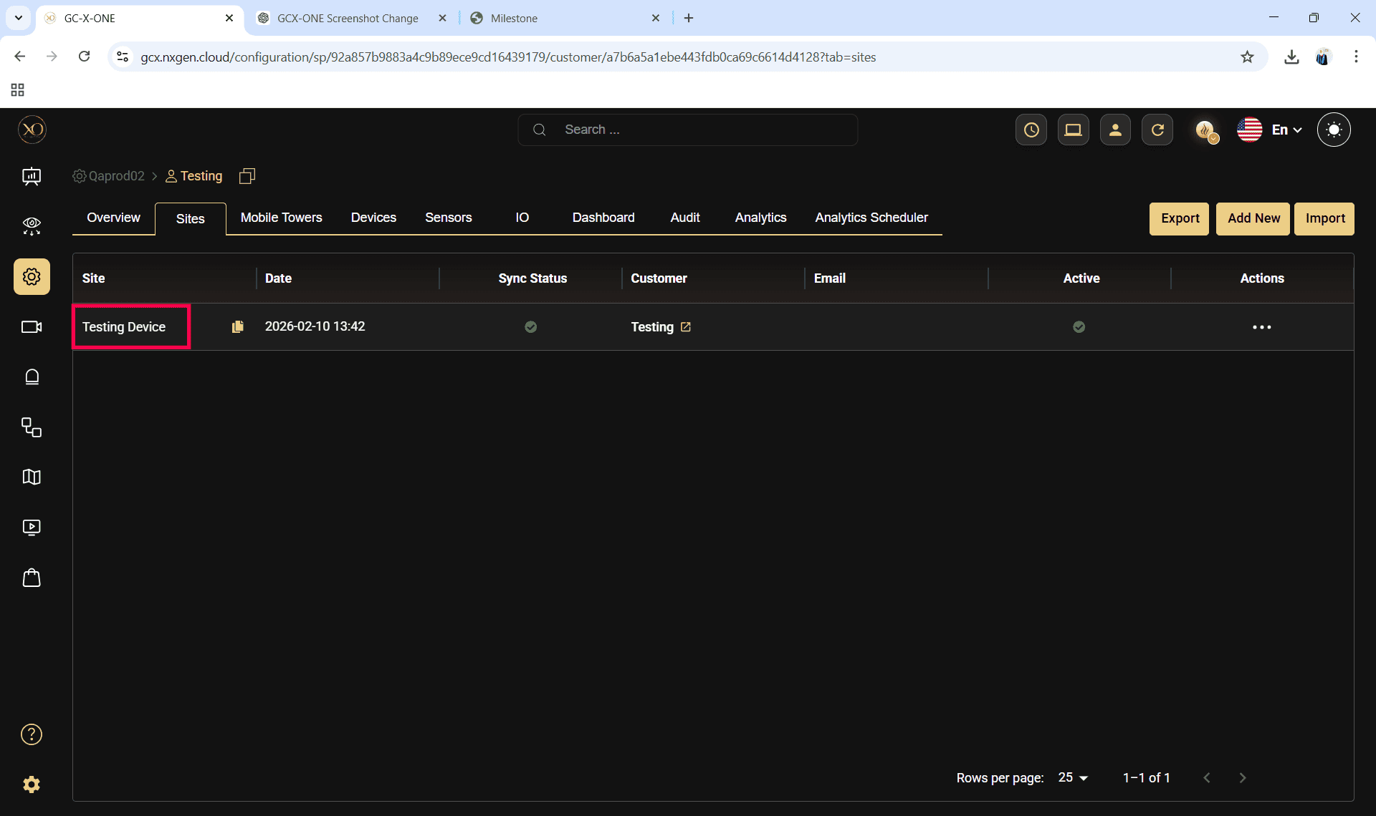
Step 11: Navigate to the Devices tab.
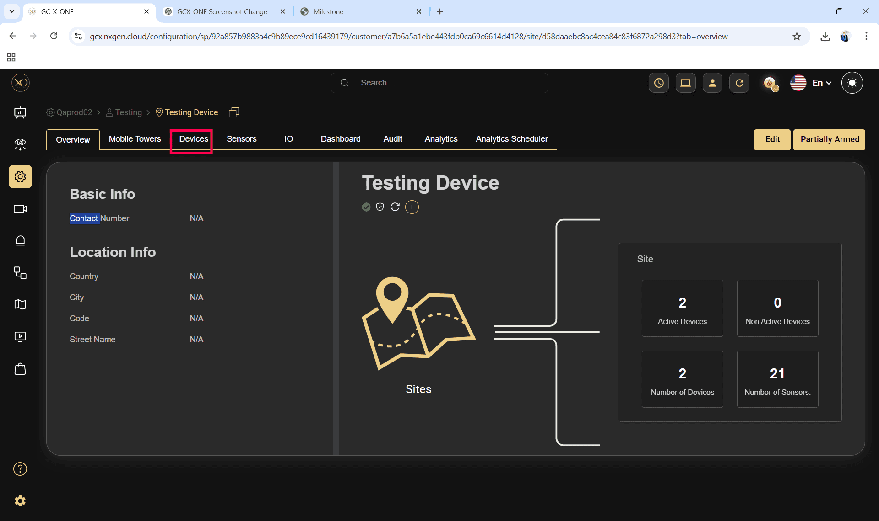

Step 12: Click the Add button.
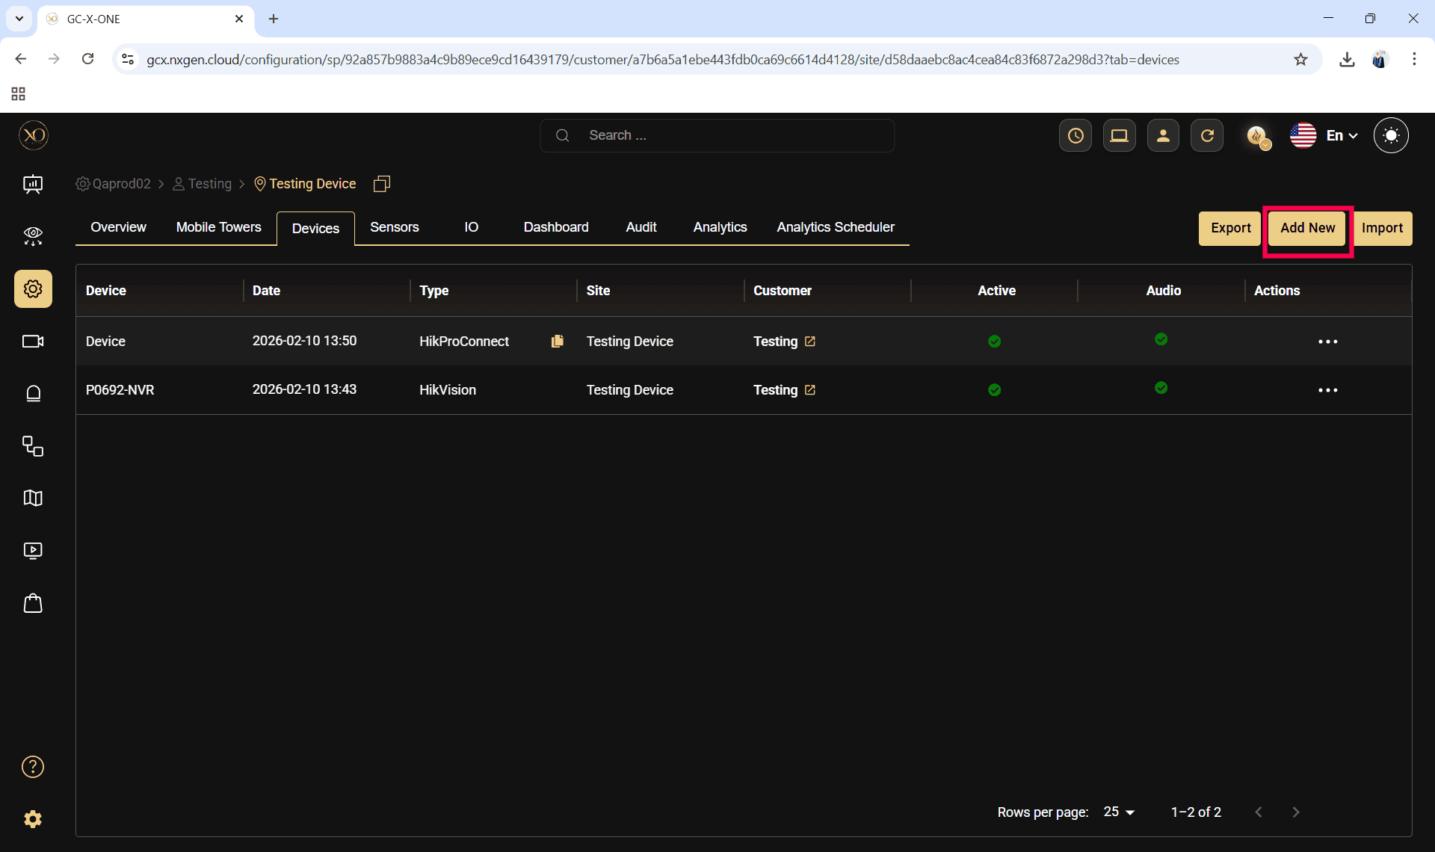

Step 13: The Add Device dialog will be displayed.
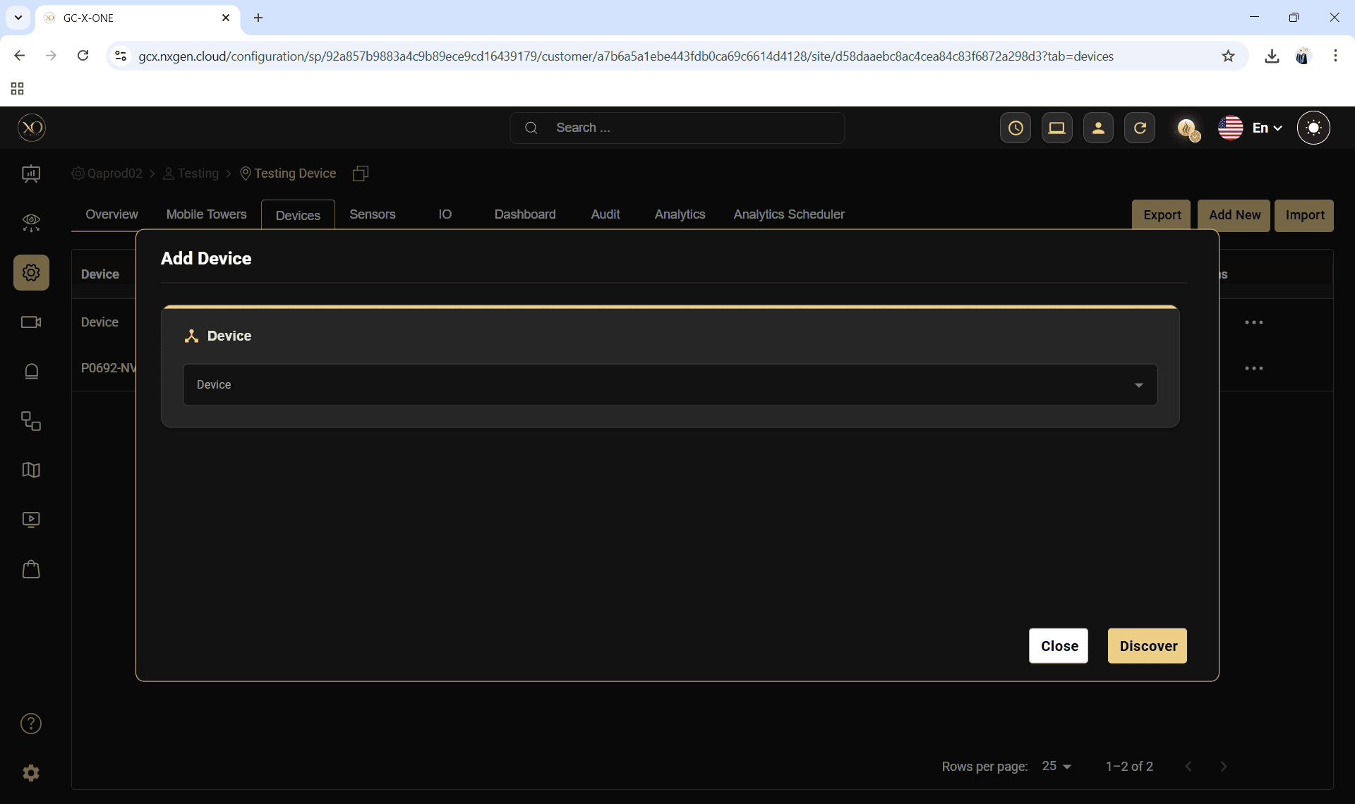

Victron Configuration in GCX-ONE
Step 14: In the dialog, open the Device dropdown and select Victron
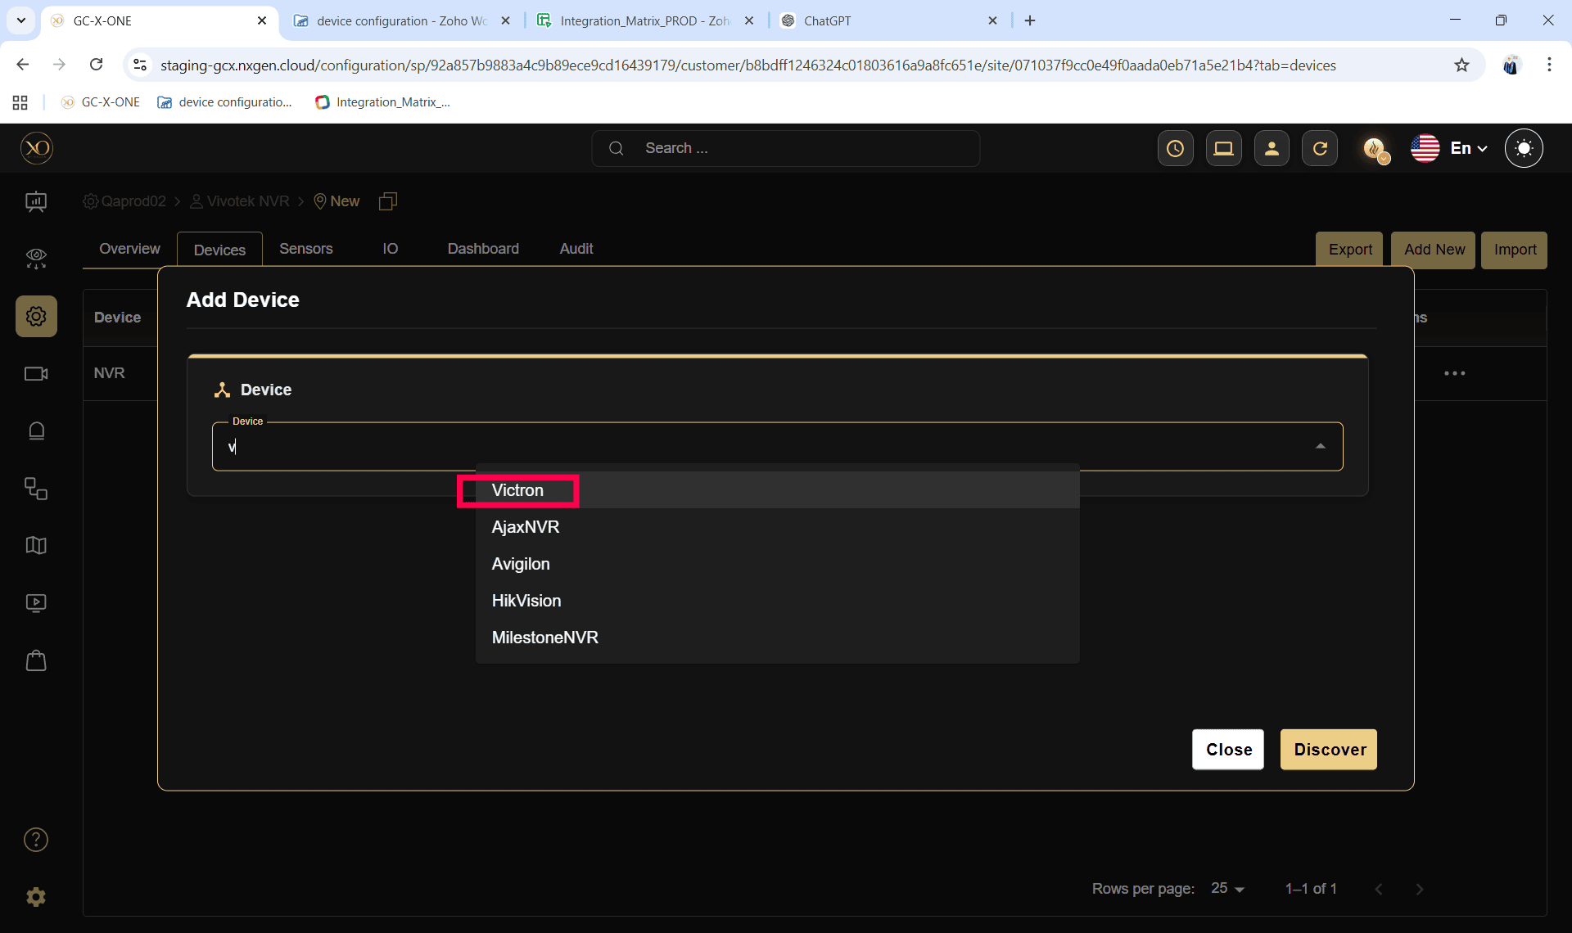

Step 15: Enter all required fields:
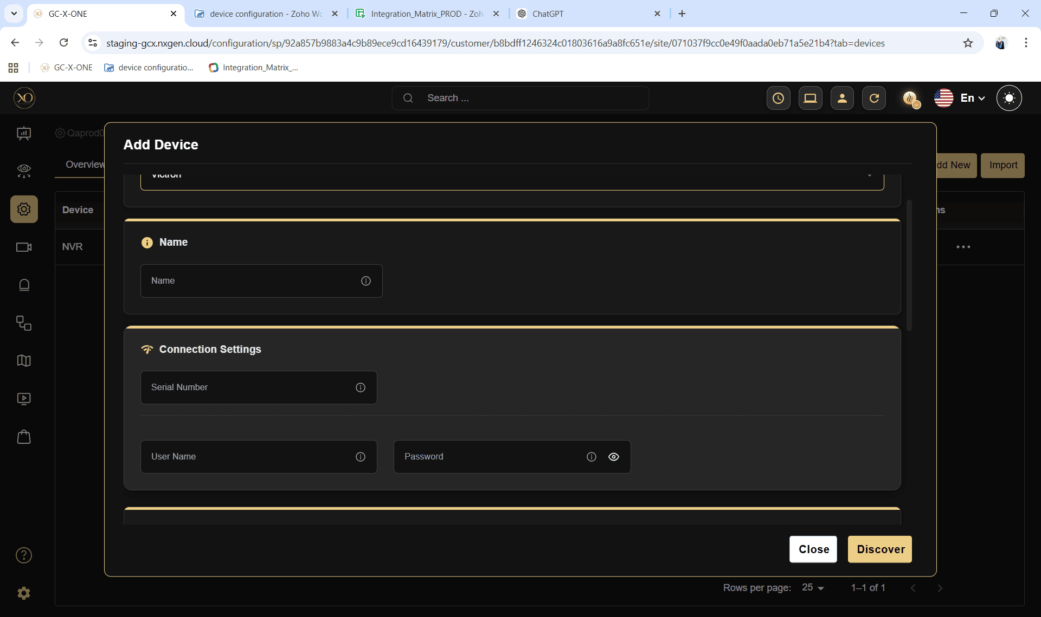
To enable Victron Energy Monitoring within GCX-ONE, the system requires certain key inputs that allow it to securely connect to the Victron VRM portal and retrieve live operational data from the associated devices.
- Device Type: Victron
- Device Name: A valid and unique name for identification in GCX-ONE.
- Serial Number: The serial number of the device, obtainable from the Victron VRM Portal.
- Username and Password: Credentials with administrative privileges to access or read the configured device in the VRM Portal.

Configuration Outcome
Once configured, GCX-ONE automatically detects the available PV Controller and Battery Manager, initiating continuous polling of the Victron API. This process enables real-time retrieval of metrics such as battery voltage, charging current, solar power generation, and overall system status. These values are then continuously evaluated against the thresholds defined under the Energy Monitoring section of your alarm rules.

EFOY Fuel Cell Monitoring Configuration
EFOY devices provide backup power generation for sites where continuous power is critical. Their configuration ensures the fuel cell remains in optimal operating condition.

EFOY Configuration in GCX-ONE

Step 14: In the dialog, open the Device dropdown and select EFOY
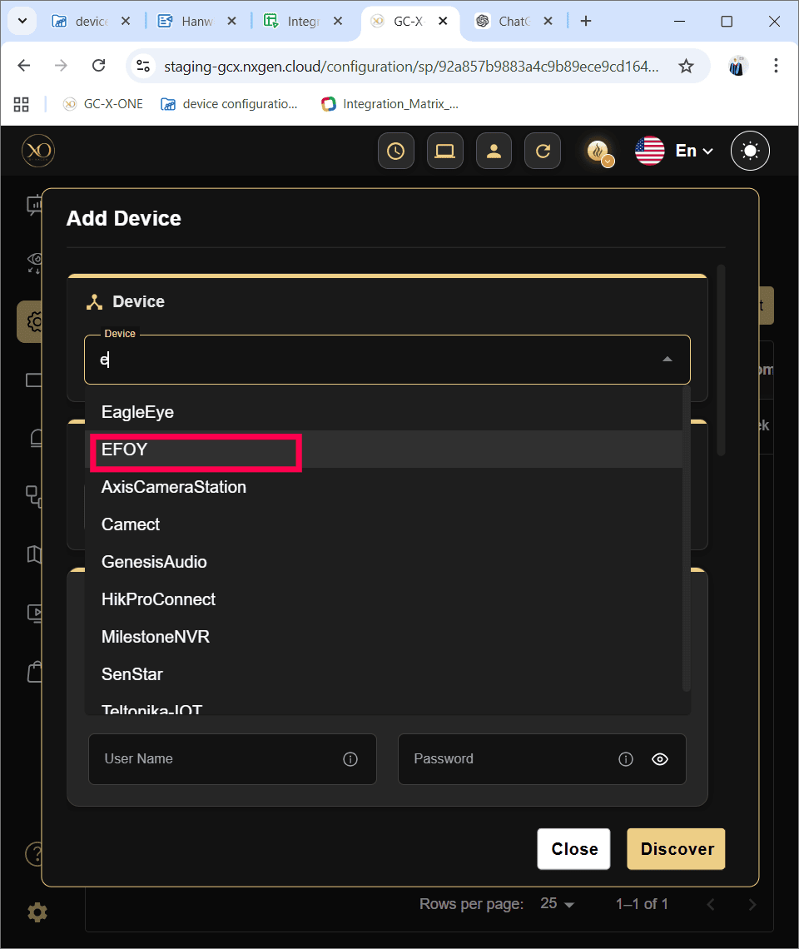

Step 15: Enter all required fields:

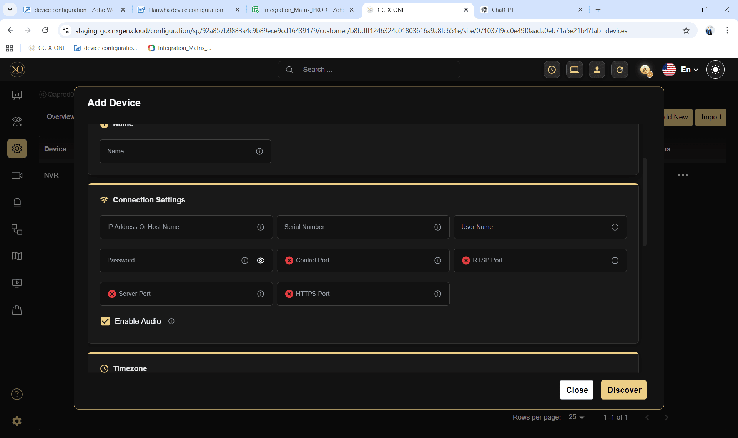
To enable EFOY Fuel Cell within GCX-ONE, the system requires certain key inputs that allow it to securely connect to the EFOY Cloud portal and retrieve live operational data from the associated devices.
- Device Type: EFOY Cloud
- Device Name: A valid and unique name for identification in GCX-ONE.
- Serial Number: The unique serial number of the fuel cell, as listed in the EFOY Cloud Portal.
- EFOY API Key: A valid API key with sufficient privileges to access all Solar and Power Controller parameters. It must be configured at Tenant level custom settings. Please find the screenshot below: 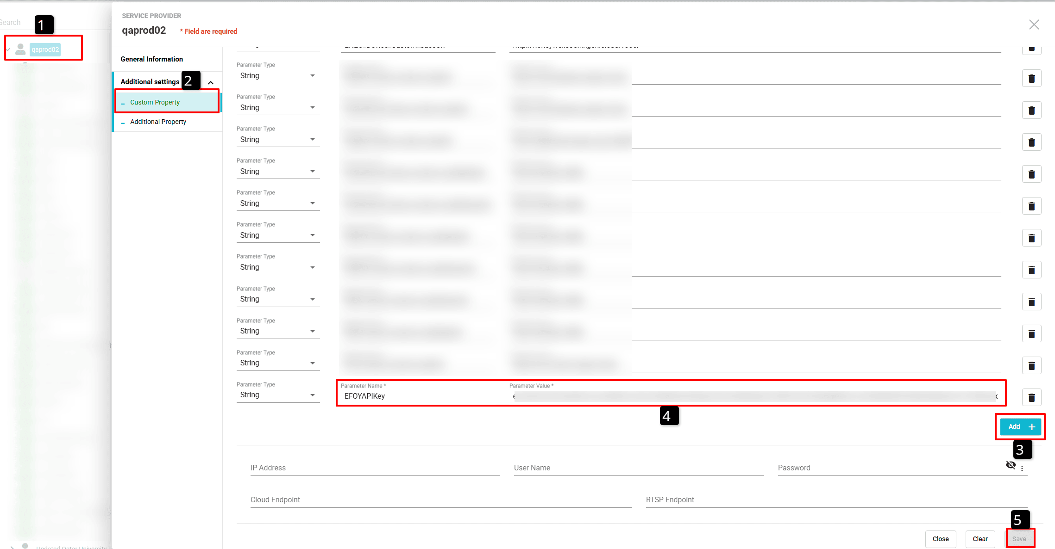
  - Select the tenant
  - Click Edit
  - Go to Custom Property
  - Click Add
  - Name the property as "EFOYAPIKey" and provide the original API key as value.
  - Click Save.

In the IP Address field, you may optionally specify the EFOY Cloud API endpoint instead of a local device address. The Username and Password fields are optional. however, you can provide valid EFOY Cloud credentials as a backup to the API key.

Configuration Outcome
Once configured, GCX-ONE connects securely to the EFOY Cloud API and begins fetching live operational data. This includes parameters such as fuel cell voltage, output power, cartridge level, energy generation rate, and system health—providing complete visibility into fuel cell performance and runtime efficiency.

Teltonika IoT Connectivity Configuration
Teltonika devices manage connectivity, communication, and environmental interaction for each tower. They report detailed I/O status, network health, SIM usage, GPS, and signal jamming conditions.

Teltonika IoT Configuration in GCX-ONE
Step 14: In the dialog, open the Device dropdown and select "Teltonika IoT"
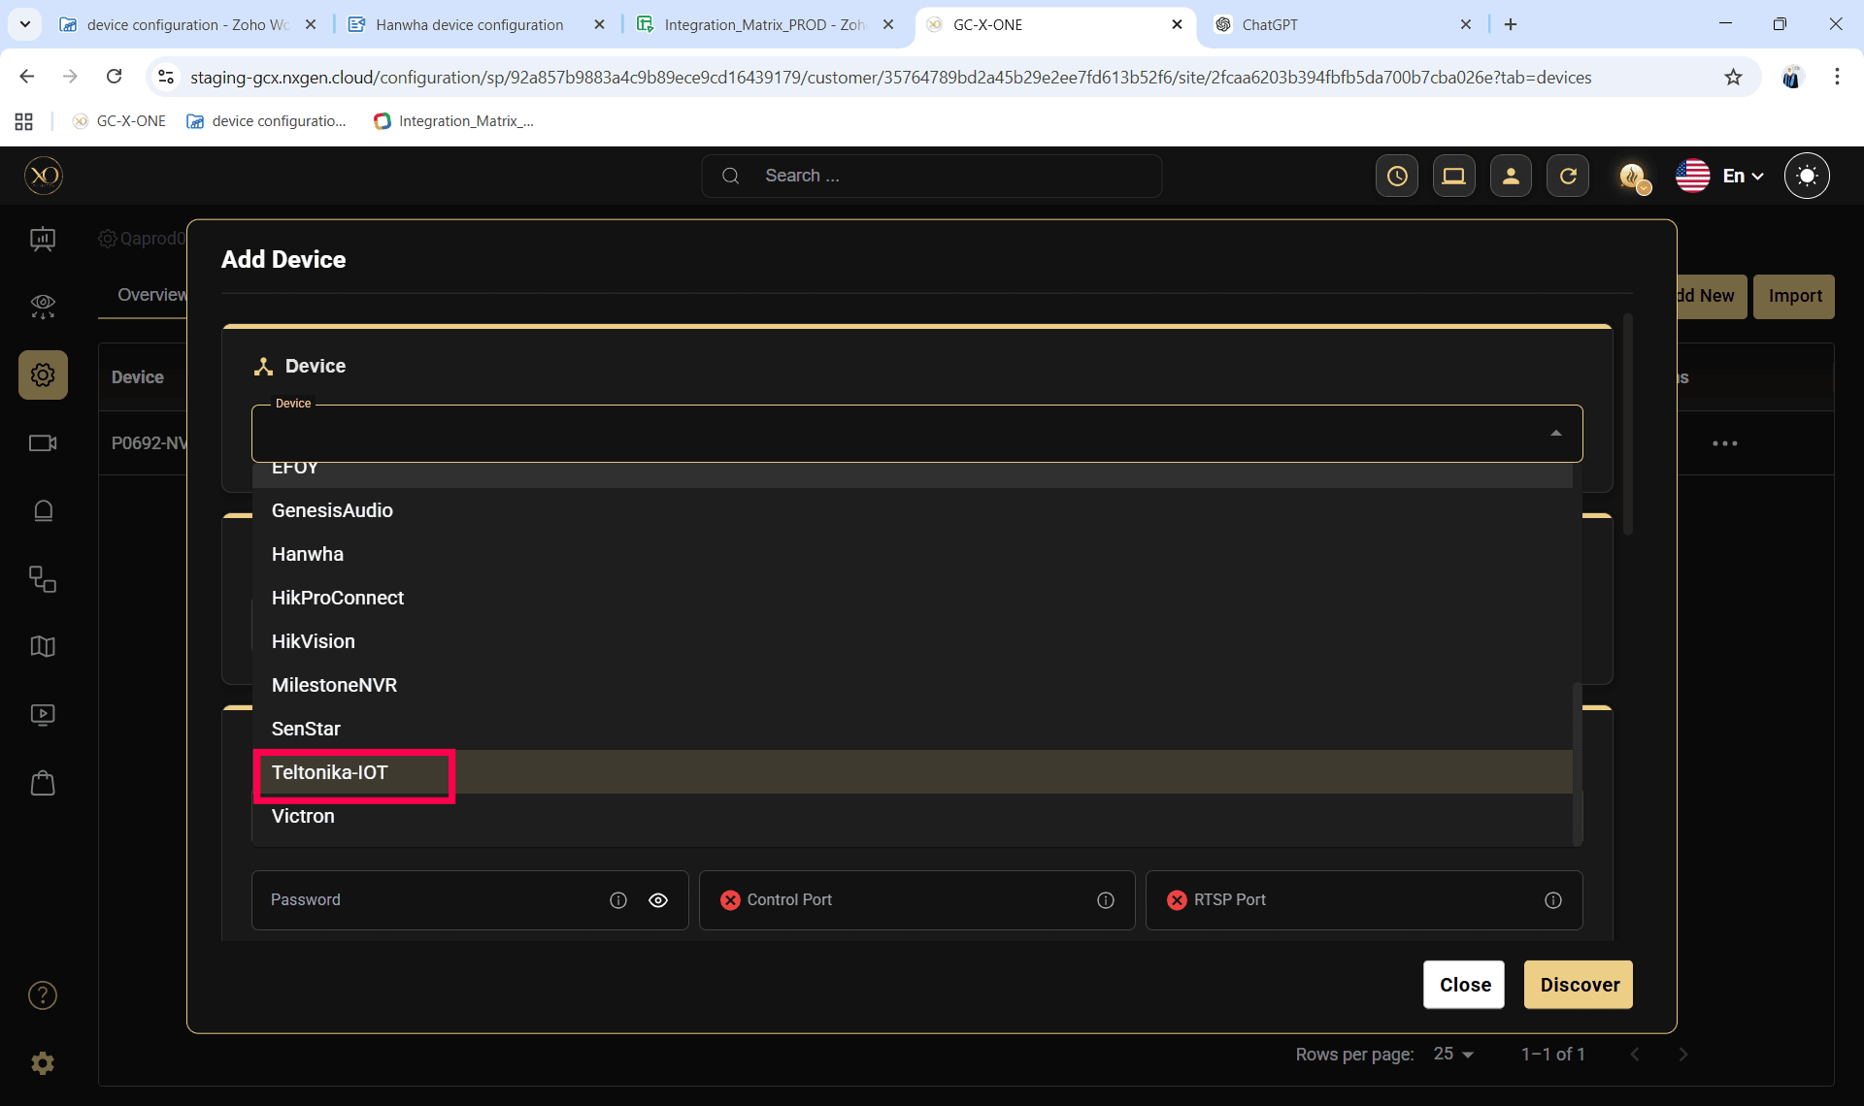

Step 15: Enter all required fields:

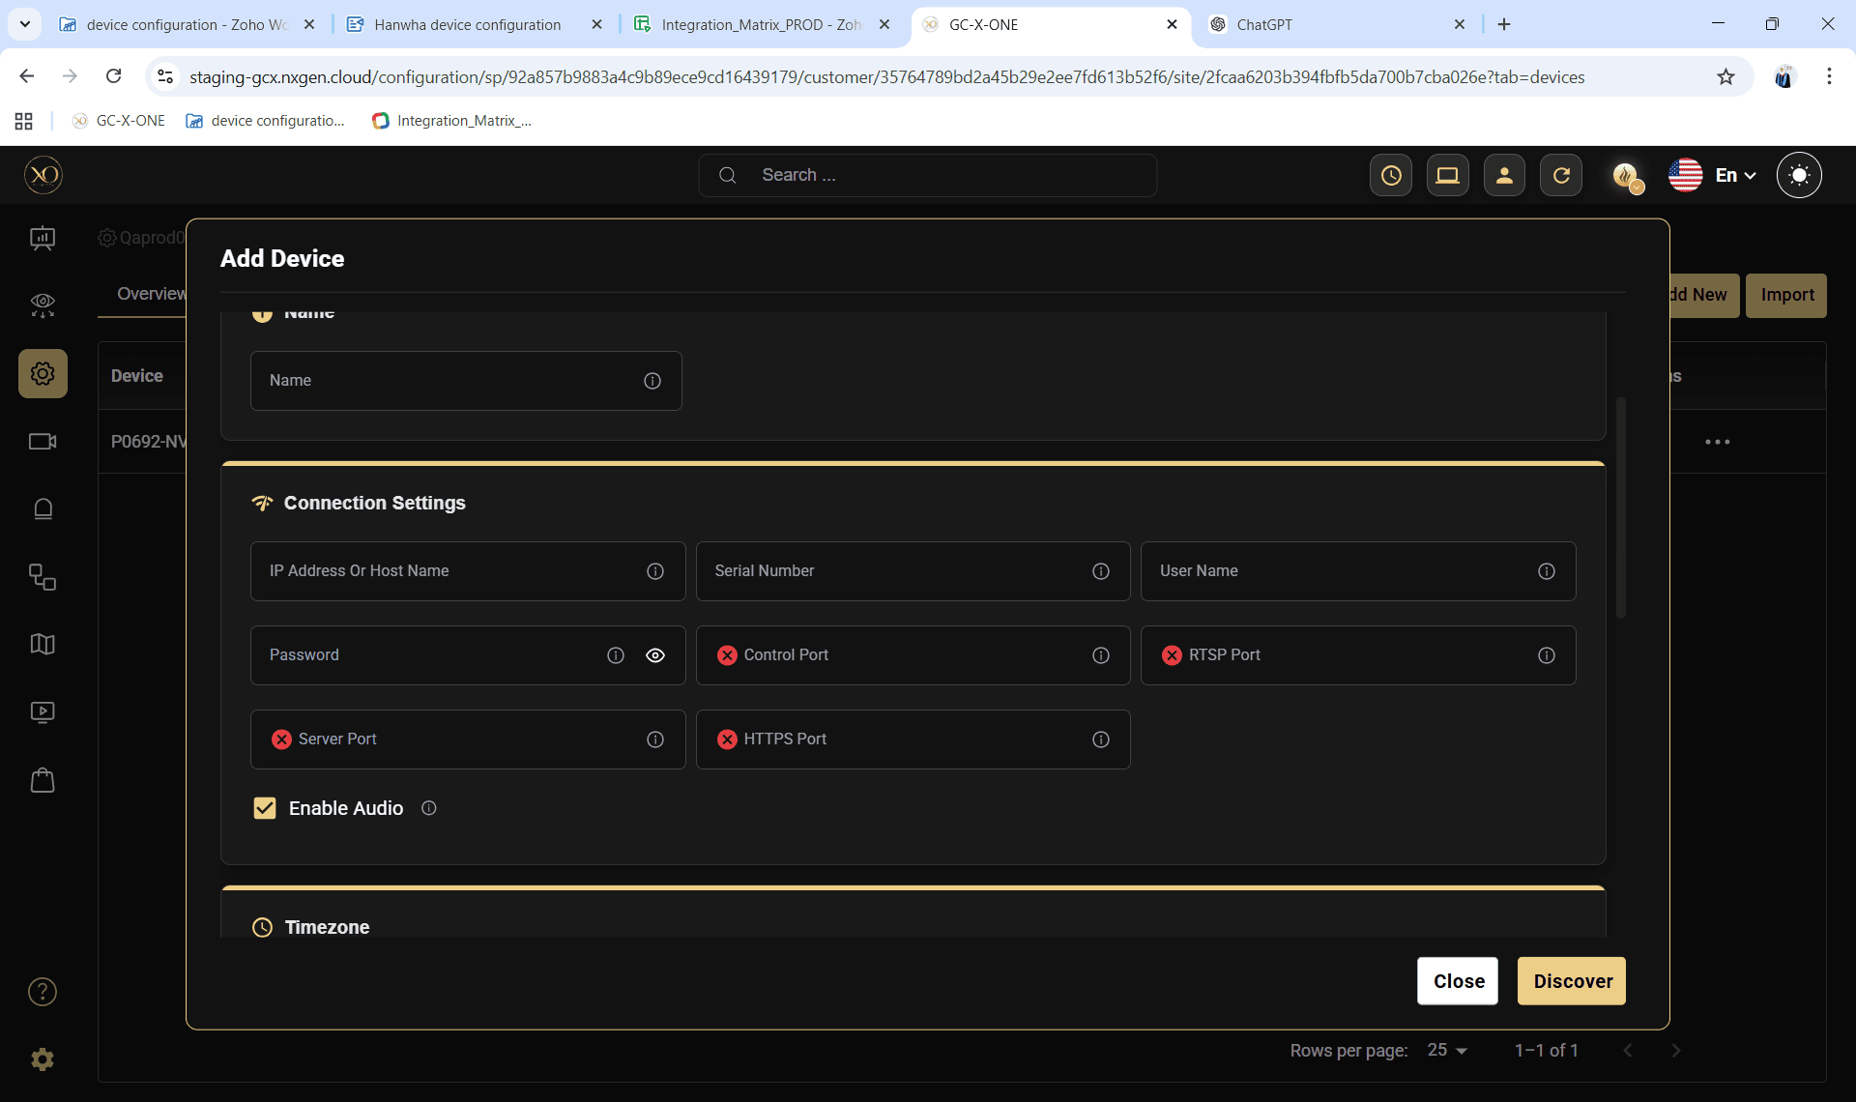
To enable Teltonika IoT Router within GCX-ONE, the system requires certain key inputs that allow it to securely connect to the router and retrieve live operational data from the associated devices.
- Device Type: Teltonika IoT
- Device Name: A valid and unique name for identification in GCX-ONE.
- IP Address: The public or VPN-accessible IP address of the Teltonika device.
- Serial Number: The unique serial number of the router.
- Control Port: The valid HTTP port used for device communication.
- Username and Password: Administrative credentials that allow full access to all device parameters and subcomponents.

Configuration Outcome
Once connected, GCX-ONE establishes a secure communication channel with the Teltonika Router, enabling continuous monitoring of key metrics such as signal strength, network uptime, connected I/O states, and environmental sensor data. Any deviations—such as loss of connectivity, abnormal input voltage, or I/O threshold breach—are automatically logged and can trigger real-time alerts to CMS.

Alarm Rules Overview
This section outlines the structure, purpose, and usage of the alarm rules configuration used for remote tower monitoring within GCX-ONE.
Each part of the configuration defines a monitored category, its key parameters, and the conditions under which alerts are raised.

Configuring Alarm Rules
The Alarm Rules in GCX-ONE are defined in JSON format, allowing precise and flexible configuration of alerting behavior.
Rules can be configured at either the Site level or Device level, depending on the monitoring scope.
To configure alarm rules:
- Navigate to the target Site or Device in GCXONE.
- Click Edit and go to the Additional Properties section.
- Locate the property named Custom Alarm Rules.
- Open the property's hamburger menu (⋮) and select Apply Default to load the preconfigured rule set. All rules are inactive by default.
- Modify the JSON to enable specific rules by setting "active": true for the relevant parameters.
- Set your thresholds, event codes, and group codes as needed.
- Click Save. GCXONE will immediately begin evaluating incoming telemetry against the configured rules.
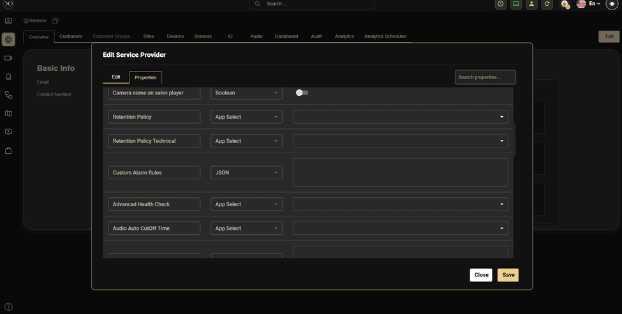

The Custom Alarm Rules configuration JSON in GCX-ONE is structured into three main sections: Energy Monitoring, Fuel Cell Monitoring, and Connectivity Monitoring.
- The Energy Monitoring section contains alert configurations specific to Victron devices, covering parameters such as battery voltage, and state of charge.
- The Fuel Cell Monitoring section defines alert rules for EFOY systems, including fuel level, voltage, temperature, and state of charge thresholds.
- The Connectivity Monitoring section manages alerts for Teltonika IoT devices, covering aspects such as network signal quality, SIM data usage, input/output status changes, and jammer detection.
This modular structure allows each device type to be independently configured while maintaining a unified monitoring and alerting framework across the entire tower system.

Victron Energy Monitoring

Battery Voltage Rule
Monitors the solar or battery voltage levels.

Default JSON Configuration
"voltage": {
"active": false,
"low": 12,
"high": 14,
"eventCode": "battery.voltage.warning",
"groupCode": "tower.solar.voltage.alert"
}
Configuration Parameters
Parameter Name | Description | Example Value
active | Enables or disables this specific alarm rule. Set to true to activate. | true
low | The lower voltage threshold. An alert triggers if the voltage falls below this value. | 12
high | The upper voltage threshold. An alert triggers if the voltage exceeds this value. | 14
eventCode | Internal event identifier used for integration with CMS or external notification systems. | battery.voltage.warning
groupCode | Group identifier used by GCX-ONE Tower Alarm Manager to categorize alerts. | tower.solar.voltage.alert

Example Behavior
- When voltage falls below 12V, an alert with event code battery.voltage.warning is raised.
- When voltage returns within range (12V–14V), GCX-ONE automatically logs the recovery event and clears the alert.
- When voltage exceeds 14V, a high-voltage warning is generated.

Battery State of Charge (SOC) Rule
Monitors the remaining charge percentage in the battery bank.
Default JSON Configuration
"stateOfCharge": {
"active": false,
"low": 15,
"eventCode": "battery.soc.warning",
"groupCode": "tower.battery.soc.alert"
}
Configuration Parameters
Parameter Name | Description | Example Value
low | Minimum acceptable SOC percentage | 15

Example Behavior
- SOC below 15% triggers low battery alert.
- Restores to normal when SOC rises above the threshold.

EFOY Fuel Cell Monitoring

Fuel Level Rule
Monitors the available fuel percentage in the EFOY fuel cartridge.
Default JSON Configuration
"Fuelevel": {
"active": false,
"low": 15,
"eventCode": "fuel.low.warning",
"groupCode": "tower.fuel.level.alert"
}
Configuration Parameters
Parameter Name | Description | Example Value
low | Minimum acceptable Fuel level | 15

Example Behavior
- Triggers a warning when fuel drops below 15%.

Voltage Rule
Monitors the EFOY power output voltage.
Default JSON Configuration
"voltage": {
"active": false,
"low": 12,
"high": 15,
"eventCode": "fuel.voltage.critical",
"groupCode": "tower.fuel.voltage.alert"
}
Example Behavior
- When voltage falls below 12V, an alert with event code fuel.voltage.warning is raised.
- When voltage returns within range (12V–14V), GCX-ONE automatically logs the recovery event and clears the alert.
- When voltage exceeds 14V, a fuel.voltage.warning warning is generated.

State of Charge Rule
Tracks the internal battery’s charge status in EFOY.
Default JSON Configuration
"stateOfCharge": {
"active": false,
"low": 15,
"eventCode": "fuel.soc.warning",
"groupCode": "tower.fuel.soc.alert"
}
Example Behavior
- Triggers an alert when SOC drops below 15%.

Temperature Rule
Monitors EFOY system temperature.
Default JSON Configuration
"temperature": {
"active": false,
"low": 10,
"high": 35,
"eventCode": "fuel.temperature.warning",
"groupCode": "tower.fuel.temperature.alert"
}
Example Behavior
- Below 10°C or above 35°C → Thermal warning.

Teltonika IoT Connectivity

Input/Output Status Change Rule
Monitors physical input/output state changes in Teltonika I/O ports.

Default JSON Configuration
"IOStatusChange": {
"input": {
"AnalogCurrentLoop": {"active": false, "low": 4, "high": 20},
"AnalogInput": {"active": false, "low": 11, "high": 14},
"DigitalInput": {"active": false, "ranges": ["Low level", "High level"], "alertOn": "High Level"},
"IsolatedInput": {"active": false, "ranges": ["Low level", "High level"], "alertOn": "High Level"},
"PowerSocketInput": {"active": false, "ranges": ["Low level", "High level"], "alertOn": "High Level"},
"eventCode": "input.statechange",
"groupCode": "tower.input.statechange"
},
"output": {
"IsolatedOutput": { "active": false, "ranges": ["Low level", "High level"], "alertOn": "High Level" },
"Relay": { "active": false, "ranges": ["open", "closed"], "alertOn": "open" },
"PowerSocketOutput": { "active": false, "ranges": ["Low level", "High level"], "alertOn": "High Level" },
"eventCode": "output.statechange",
"groupCode": "tower.output.statechange"
}
}
Analog Current Loop
Field | Description
active | Enables 4–20 mA loop monitoring (true/false)
low / high | Defines acceptable current range.
eventCode | input.statechange
groupCode | tower.input.statechange

Analog Input
Field | Description
active | Enables analog voltage input monitoring (true/false)
low / high | Acceptable range (e.g., 11–14 V).
eventCode | input.statechange
groupCode | tower.input.statechange

Digital / Isolated / Power Socket Inputs
Field | Description
active | Enables input monitoring (true/false)
ranges | Possible states, e.g., ["Low level", "High level"].
alertOn | State that should trigger an alarm (e.g., “High Level”).
eventCode | input.statechange
groupCode | tower.input.statechange

Isolated / Power Socket Outputs
Field | Description
active | Enables Output monitoring (true/false)
ranges | Possible states, e.g., ["Low level", "High level"].
alertOn | State that should trigger an alarm (e.g., “High Level”).
eventCode | output.statechange
groupCode | tower.output.statechange

Relay Output
Field | Description
active | Enables relay trigger monitoring (true/false)
ranges | Possible states, e.g., ["open", "closed"].
alertOn | Tracks relay states (e.g., “open”).
eventCode | output.statechange
groupCode | tower.output.statechange

SIM Card Data Package Usage Rule
Tracks mobile data consumption for Teltonika routers.
Default JSON Configuration
"simCardDataPackage": {
"active": false,
"simBillingStartDate": 1,
"simDataPackageGB": 10,
"usageWarningPercent": 80,
"eventCode": "sim.data.usage.warning",
"groupCode": "tower.connectivity.simdata.alert"
}
Configuration Parameters
Parameter Name | Description | Example Value
simBillingStartDate | Billing cycle start date of the SIM plan (currently inactive) | 1
simDataPackageGB | Total mobile data allocated per month (in GB) | 10
usageWarningPercent | Warning threshold as a percentage of total data usage | 80

Example Behavior
- Triggers an alert when data usage exceeds 80% of 10GB.

Cellular Network Loss Rule
Detects loss of mobile network connectivity.
Default JSON Configuration
"cellNetworkLoss": {
"active": false,
"eventCode": "modem.signal.warning",
"groupCode": "tower.connectivity.signal.alert"
}
Example Behavior
An alert is triggered when the network signal drops very low. GCX-ONE automatically clears the alert when the signal returns to acceptable range.

Geo-Fencing Rule
Monitors device location relative to its assigned site.
Default JSON Configuration
"geoFencing": {
"active": false,
"radiusMetersWarning": 500,
"eventCode": "geo.fence.breach",
"groupCode": "tower.connectivity.geofence.alert"
}
Configuration Parameters
Parameter Name | Description | Example Value
radiusMetersWarning | Radius (in meters) from the defined geo-fence center (typically, the site's geo location) within which the tower must remain | 500

Example Behavior
This rule continuously monitors the GPS coordinates reported by the Teltonika router or GPS module.
If the device moves outside the configured radius, GCX-ONE generates an alert indicating a potential tower displacement or unauthorized movement.
The location boundary is defined by the configured coordinates of the parent Site, ensuring that alerts are triggered only when the tower moves beyond its designated operational area.
The alert is automatically cleared when the tower returns within the defined site boundary.

Jammer Detection Rule
Default JSON
"jammerDetection": {
"active": false,
"criteria": {
"signalDropThreshold": 25,
"minSignalLevel": -113,
"rsrqThreshold": -20
},
"eventCode": "modem.jammer.detected",
"groupCode": "tower.connectivity.jamming.alert"
}
Configuration Parameters
Parameter Name | Description | Example Value
signalDropThreshold | Percentage drop in signal strength considered as a potential jamming event | 25
minSignalLevel | Minimum acceptable signal level (in dBm); if signal goes below this, jamming is suspected | -113
rsrqThreshold | Minimum acceptable RSRQ (Reference Signal Received Quality); poor RSRQ may indicate interference | -20

Example Behavior
This rule detects potential network jamming attempts based on sudden signal degradation and poor RSRQ quality.
If the signal drop percentage exceeds the configured threshold or the RSRQ value falls below the acceptable range, GCX-ONE triggers a jamming alert.
The alert clears automatically once normal signal stability is restored.

Configuration Notes
- Each rule has an active flag. When false, the system skips that rule.
- Thresholds can be adjusted per site depending on environmental conditions.
- Event Codes are unique identifiers used internally within GCX-ONE for system integrations — particularly for notifying external Central Monitoring Systems (CMS) or third-party applications. They ensure consistent and standardized communication of alarm events across different platforms.
- Group Codes, while similar in structure to Event Codes, are specifically utilized within the Tower Monitoring Environment. They serve as logical identifiers for grouping related alarms, enabling efficient organization, filtering, and management of events within GCX-ONE and its tower-level alerting workflows.

